FF0000 = Red
00FF00 = Green
0000FF = Blue
FFFFFF = White
000000 = Black

File Key: index.css = IDX · master.css = MST · search.css = SEA · timeline.css = TIM
Hex | CSS file(s)
#000000 | MST,
#00000000 | MST, TIM (transparent)
#00527659 | TIM
#00AEBD | MST, TIM
#07277C85 | MST, TIM
#08236A59 | TIM
#087EAA | MST, TIM
#087ECB | MST, TIM
#0D5B92 | MST
#103BA9 | MST, TIM
#104BBD | TIM
#123DB8 | IDX, MST, TIM
#123DB81A | IDX, MST
#123DB81F | MST
#123DB829 | TIM
#123DB82E | MST
#123DB833 | MST, TIM
#123DB83D | MST, TIM
#123DB840 | MST
#13AEBE | MST, TIM
#13C8D5 | MST, TIM
#13C8D514 | MST
#13C8D51A | MST
#13C8D51F | MST
#13C8D533 | MST
#13C8D5CC | MST
#1455E8 | IDX, MST, SEA, TIM
#1455E809 | TIM
#1455E80F | MST
#1455E814 | MST
#1455E81A | TIM
#1455E81F | TIM
#1455E829 | IDX, MST
#1455E82E | MST
#1455E833 | SEA, TIM
#16227F | MST
#172640 | IDX, MST, TIM
#1766F4 | MST, TIM
#1B346421 | TIM
#1B34642E | TIM
#1D243014 | MST
#201C30 | TIM
#222222 | MST
#283449 | TIM
#303C4D | MST
#333333 | MST
#52C4E8 | TIM
#53657D | MST
#7F1629 | MST
#7F16291F | MST
#8A5A004C | TIM
#8BB5FF | MST
#8BDCF0 | TIM
#A8E8F3 | MST
#B9E9F5 | MST, TIM
#DCEAFF | MST, TIM
#DDDDDD | MST, SID
#E9FBFF | TIM
#EAF2FF | IDX, MST, SEA, TIM
#EAF2FFCC | MST
#EDF5FF | MST, TIM
#F2BB06 | MST
#F2F7FF | MST, TIM
#F5EFE5B2 | MST
#F7EFE4 | MST
#F7F2E8E6 | MST
#F7FAFF | IDX, MST
#F8F4EF | MST
#F8FBFF | SEA, TIM
#FFDC45CC | TIM
#FFF9F5 | MST
#FFFEF9 | TIM
#FFFFFF | MST, SEA, TIM
#FFFFFF09 | TIM
#FFFFFF14 | MST
#FFFFFF2E | MST
#FFFFFF38 | MST, TIM
#FFFFFF47 | TIM
#FFFFFF57 | TIM
#FFFFFF59 | MST, TIM
#FFFFFF6B | MST
#FFFFFF80 | MST
#FFFFFF8C | TIM
#FFFFFFB2 | MST
#FFFFFFB8 | MST
#FFFFFFE0 | IDX, MST
#FFFFFFF0 | MST

Top menu background: #1242c3 or --denim: #123db8;

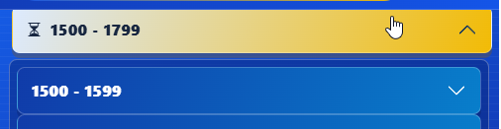
Colour used for selected Century button. Lines 79 -86 of timeline.css
.timeline-page .sidebar .accordion-button:not(.collapsed) {
background: linear-gradient(
110deg,
var(--timeline-seashell-blue),
#f2bb06) !important;
color: var(--timeline-ink) !important;
box-shadow: 0 5px 0 rgba(138, 90, 0, 0.3) !important;
}


Colours used when hovering over century buttons lines 68 – 73 of timeline.css
.timeline-page .sidebar .accordion-button:hover {
transform: translateX(3px);
background: linear-gradient(110deg, #00aebd, #f2bb06)!important;
color: var(--timeline-ink) !important;
box-shadow: 0 5px 0 rgba(0, 82, 118, 0.35) !important;
}

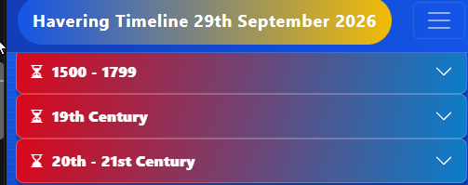

Colours used for century buttons when idle. Lines 48 – 62 of timeline.css
.timeline-page .sidebar .accordion-button {
min-height: 48px;
padding: 0.75rem 0.85rem;
border: 1px solid rgba(255, 255, 255, 0.22) !important;
border-radius: 8px !important;
background: linear-gradient(110deg, #db0719, #087ecb) !important;
color: #fff !important;
font-weight: 800;
letter-spacing: 0.015em;
box-shadow: 0 5px 0 rgba(8, 35, 106, 0.35) !important;
transition:
transform 160ms ease,
background-color 160ms ease,
box-shadow 160ms ease;
}

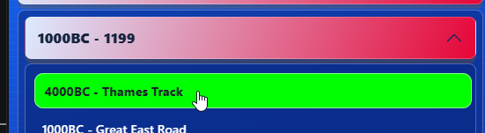
Colour used for hover on selected year lines 121 – 126 on timeline.css
.timeline-page .sidebar .nav-link:hover {
transform: translateX(3px);
border-color: rgba(255, 255, 255, 0.55);
background:#00ff00 !important;
color: #201c30 !important;
}
Now set to #f2bb06
